Efficient Integrated Model Predictive Control of Urban Drainage Systems using Simplified Conceptual Quality Models

Congcong Sun^{1*}, Bernat Joseph-Duran², Thibaud Maruejouls³, Gabriela Cembrano^{1,2}, Eduard Muñoz⁴, Jordi Meseguer², Albert Montserrat³, Sara Sampe², Vicenç Puig¹ and Xavier Litrico³
1 Advanced Control Systems Group at the Institut de Robòtica i Informàtica Industrial (CSIC-UPC), Barcelona, Spain
2 CETaqua, Water Technology Centre, Barcelona, Spain
3 LyRE, Suez Eau France Research Center, Talence, France.
4 AQUAMBIENTE SERVICIOS PARA EL SECTOR DEL AGUA, SAU, Suez Eau France Research Center, Barcelona, Spain
* Corresponding author’s e-mail: csun@iri.upc.edu

Summary
Integrated control of urban drainage systems considering urban drainage networks (UDN), wastewater treatment plants (WWTP) and the receiving environment seeks to minimize the impact of combined sewer overflow (CSO) to the receiving environment during wet weather. This paper will show first results of the integrated control of UDN and WWTP, obtained by LIFE-EFFIDRAIN, which is a collaborative project between academia and industry in Barcelona (Spain) and Bordeaux (France). Model predictive control (MPC) is applied for strategy optimization using conceptual hydraulic and quality variables, where the total suspended solid (TSS) concentration is selected as a representive of water quality. SWMM5 integrated with a lumped conceptual model of TSS (SWMM-TSS) is applied as virtual reality. The Perinot sewer network from Bordeaux is used as a case study for functional demonstration.

Keywords
Urban Drainage Network, Conceptual Quality Models, Combined sewer overflow, MPC, TSS, WWTP

Introduction
Real-time control (RTC) of urban drainage networks (UDN) has emerged since 1970s, which promoted a greater acceptance of RTC by the municipal engineers and managers of UDN (Beck, 1976; Schilling, 1989; Schutze et al., 2002; Schutze et al., 2004). Among RTC techniques, model predictive control (MPC) has been proven as an efficient technique to compute optimal strategies for UDN ahead in time, based on hydrology/hydraulics models, measurements and rain intensity forecasts (Puig et al., 2009; Ocampo-Martinez et al., 2012). Nowadays, UDN and wastewater treatment plants (WWTPs) are mostly operated separately, using different operational goals. Besides that, for MPC of UDN, the issue of quality modelling has not been included directly in the strategy optimization problem.
Because of the data uncertainty and calibration difficulty, modelling the generation and transportation of pollution in UDN in a storm event is complex. In (van Rijn, 1984; Rouse, 1937; Macke, 1980; Ackers and White, 1973), some physically-based models to represent quality dynamics in UDN are proposed but with high computational time requirement. Taking into account the complexity of the quality spatial/temporal evolution in UDN, appropriate conceptual quality models are required to apply MPC efficiently in UDN, which should allow the MPC to compute estimations of the quality evolution in the UDN during a storm event (Ahyerre et al., 1998).

The LIFE EFFIDRAIN project aims to develop an approach for integrated MPC of UDN and WWTP to minimize polluting loads of CSO using real-time quantity and quality data, to be demonstrated in Bordeaux and Barcelona real-life pilots. First results of LIFE EFFIDRAIN will be provided here using a section of the Bordeaux network, an area called Perinot.

Materials and Methods
The processes of developing integrated MPC will require the development of:
- Simplified models of quality and hydraulics for all elements in the UDN and the WWTP;
- Performance indexes taking into account both quantity and quality of CSO;
- Implementation of integrated MPC control strategy;
- Test on different rain scenarios with different initial conditions (e.g.: antecedent dry days).

Simplified Modelling Approaches
TSS has been selected as representive of water quality because it can be correlated to the turbidity measurements, which can be obtained online and it can provide estimations for other quality variables.
Physically, TSS models are affected by sediment solid accumulation over urban catchments; sediment solid washoff by rainfall; transport, erosion and deposition of solids in sewer networks and detention tanks (Bertrand-Krajewski, 2006; Rossman, 2015).
The proposed conceptual modelling approaches are designed to predict the evolution of TSS over the predictive control horizon.
The simplified dynamic behavior of TSS in UDN will be provided in the modelling approach for TSS deposition and erosion in detention tanks based on the hydraulic model and definition of TSS; TSS transport in a sewer and mass balance equation in the junction. The parameters of the simplified models are calibrated using a detailed simulator as a virtual reality. The least square fitting index is used to measure the goodness of approximation of the simplified model.

Detention Tank

Fig. 1.Simple graph of detention tank.
Taking detention tank as an example (shown in Fig. 1), where hydraulic in a detention tank can be written as equation (1) (Cembrano et al., 2004; Puig et al., 2009; Sun et al., 2017):
$V\left(k+1\right)=V \left(k\right)+ Δt(Q_{in}\left(k\right)-Q_{out}\left(k\right))$ (1)
where V is tank volume, k is time instant, $Δt$ is control interval, Q are flows of this tank.
Assuming M, TSS are total mass and concentration of suspended solids in the tank, simplified M is proposed as equation (2):
$M\left(k+1\right)=\left(1-a\right)M \left(k\right)+ Δt(Q_{in}\left(k\right){TSS}_{in}\left(k\right)-Q_{out}\left(k\right){TSS}_{out}\left(k\right))$ (2)
where α is a parameter taking values between -1 and 1 to represent sedimentation or erosion effects in the tank.
Then, the concentration of suspended solids in the tank, and also in the outlets is (valid for V > 0):
${TSS}_{out}\left(k+1\right) = \frac{M\left(k+1\right)}{V \left(k+1\right)}$ (3)

Model Performance Evaluation
In order to validate and compare implementations of the proposed modelling approaches, the least square fitting index is used to evaluate model performance comparing the simplified model with simulated results produced by lumped model of SWMM-TSS (Sun et al., 2017).
$FC=\sum_{k=1}^{K}{{(V\left(k\right)-R(k))}^{2}}$ (4)
where V means the calibrated value using simplified model and R is the simulated value using SWMM-TSS.
Besides, the fitting rate between the estimation provided by the simplified model and the simulated value with SWMM-TSS is defined using Nash Sutcliffe model efficiency coefficient (Nash and Sutcliffe, 1970):
$\overline{V}= \frac{\sum_{k=1}^{K}{V(k)}}{K}$ (5)
${FC}_{TSS}=100 (1- \frac{\sqrt{\sum_{k=1}^{K}{{(R\left(k\right)-V(k))}^{2}}}}{\sqrt{\sum_{k=1}^{K}{{(R\left(k\right)-\overline{V}(K))}^{2}}}})$ (6)

Model Predictive Control
The main idea of integrated MPC proposed in LIFE-EFFIDRAIN is to operate all the subsystems (e.g.UDN, WWTP and receiving body) more efficiently rather than increasing the storage capacity of the sewer network. Proposals of control-oriented integrated models can be found in (Meirlaen et al., 2002; Vanrolleghem et al., 2005) (based on the integrated model simulator WEST), (Schütze et al. 2002; Butler and Schütze, 2005) (based on SAMBA/MOUSE simulator for the hydraulic sub-model) and (Fu et al., 2008).

State Space Equation
The hydrology/hydraulics dynamic model of the integrated UDN and WWTP systems will be represented by state space equations (7)(8)(9):
$x_{t}\left(k+1\right)=f(x_{t}\left(k\right),u\left(k\right),d\left(k\right))$ (7)
$x_{t}^{min}<x_{t}\left(k\right)<x_{t}^{max}$ (8)
$u^{min}<u\left(k\right)<u^{max}$ (9)
where $x_{t}$ is a vector of network states (e.g. water volume and TSS mass in a tank); $u$ is a vector of control variables such as flow across a commanded gate; $d$ is a vector of disturbances related to rain intensity and runoff.

Performance Index
An optimization problem of MPC includes an objective function (O.F), which is normally a weighted aggregation of various goals according to the given optimization problem. The main control objectives of LIFE EFFIDRAIN are (Ocampo-Martinez et al., 2013; Mahmood et al., 2017):
- Minimization of CSO to the receiving environment. CSO is produced when untreated sewage flows reach a spillway to the receiving environment. This situation must also be avoided, whenever possible. At each time instant the following expression must be minimized:
$J_{1}\left(k\right)= \left\{\begin{aligned}{\left(u^{cso}\left(k\right)-u^{opt}\right)}^{T}\left(u^{cso}\left(k\right) -u^{opt}\right) if u^{cso}\left(k\right)>u^{opt}, \\ 0 otherwise,\end{aligned} \right.$ (10)
where $u^{opt}$ is the maximal flow allowed of $u^{cso}$ just before releasing sewage to the receiving environment. This term can be seen as a special case of the first objective where only the overflows going to the receiving environment are taken into account.
- Minimization of TSS mass discharge to the receiving environment. This objective is try to optimize the pollutant (here is TSS) released together with CSO to the receiving environment, which can be minimized:
$J_{2}\left(k\right)= {{(TSS}_{out}^{cso}\left(k\right)*u^{cso}(k))}^{T}{(TSS}_{out}^{cso}\left(k\right)*u^{cso}(k))$ (11)
where ${TSS}_{out}^{cso}$ is the TSS concentration for the CSO flow $u^{cso}$.
- Maximize WWTP usage. This objective aims at reducing the amount of untreated sewage that is released to a received environment, this is achieved by minimizing:
$J_{3}\left(k\right)={(u^{ww}\left(k\right)-u^{wwtp})}^{T}(u^{ww}\left(k\right)-u^{wwtp})$ (12)
where $u^{wwtp}$is the maximum allowed flow into the WWTP for the related flow $u^{ww}$.
The multi-objective performance index $J(k)$ that gathers the aforementioned control objectives in the case of UDN and WWTP can be written as:
$J\left(k\right)= \sum_{j=1}^{φ}{r_{j}J_{i}(k)}$ (13)
Where a set of $φ$ control objectives are considered and, in turn, a multi-objective open-loop optimization problem (OOP) is stated. The prioritization of the control objectives is performed by using the order of the mathematical cost function associated to each objective, and also a set of appropriate weights $r_{j}$ (Ocampo-Martinez et al., 2013; Mahmood et al., 2017).

Closed-loop Simulation and Optimization Solver
As shown in Figure 2, the closed-loop simulation and optimization solver is used in this paper. Where MPC strategy is optimized with GAMS optimization library (Richard, 2016), using conceptual models for both UDN and WWTP. The produced control action set-points will be sent to the virtual reality simulated by SWMM-TSS and Matlab, a new quality model based on SWMM5 (Rossman, 2015) has been developed at LyRE (R+D Centre of Suez) to reproduce TSS transport, sediment accumulation and erosion in sewers (Wiuff, 1985) and retention tanks (Maruejouls et al, 2012). This quality model in SWMM-TSS uses the extended Barre de Saint Venant equation set from SWMM5, the detailed structure of SWMM-TSS is explained in Figure 3. Measurements from simulation are sent to optimizer for the next iteration.

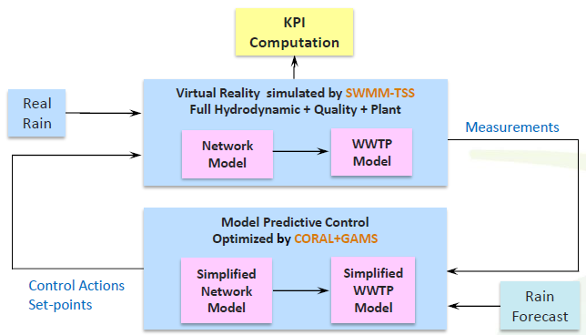

Fig. 2. Closed-loop Optimization and Simulation System

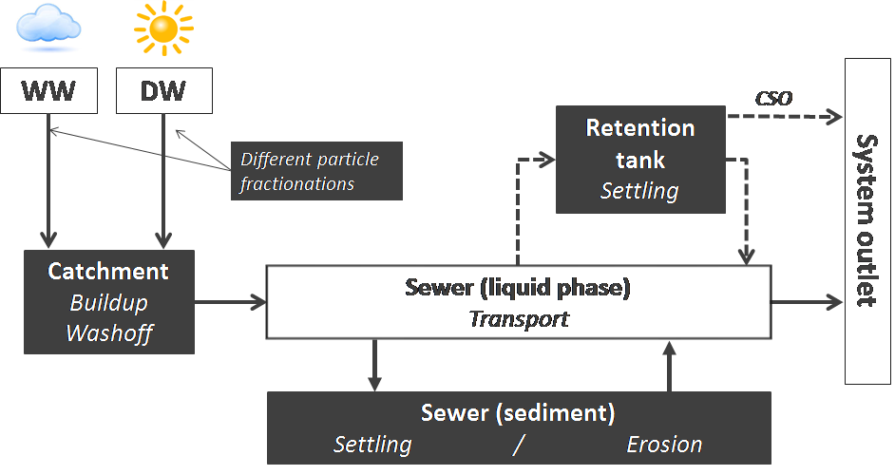
Fig. 3. SWMM-TSS, white boxes are existing modules, grey boxes are added quality modules

Case Study
The case studies of the LIFE EFFIDRAIN projects are taken from real systems of Badalona (Spain) and Bordeaux (France). The paper will present results on the Perinot sewer network (Figure 4), which is part of the urban drainage network in Bordeaux Métropole.
The real case study of the sewer of Perinot in Louis Fargue catchment of Bordeaux Metropole covers a total area of 260 ha that is mainly residential. The sewer length is 3 km with an average slope of 0:007, quite constant over the whole catchment. The detention tank is separated in three hydraulically connected volumes for a total storage volume of 35 000 m3. Even if the slope is generally low, there is no sediment issues on the sewer reported from the operators.

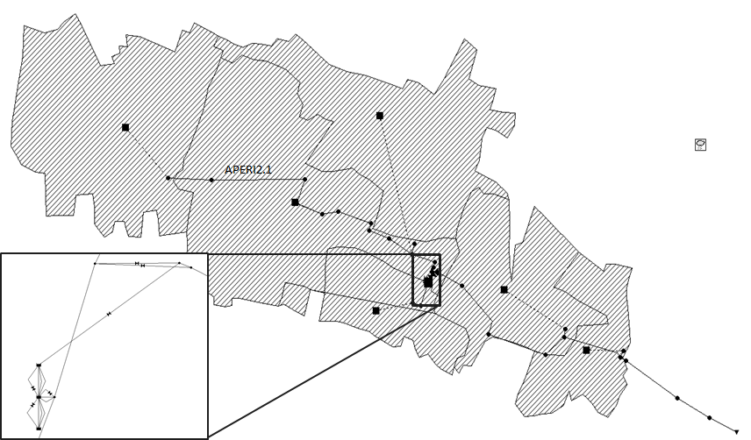
Fig. 4.Perinot Sewer Network.

Results and Discussions

In order to calibrate the proposed simplified modelling approach for detention tank, tank PER2 has been selected to produce TSS training data using SWMM-TSS. Rain scenario used for calibration of the simplified models corresponds to the real rainfall measured at Lyon, France in the year of 2007.

A rain scenario with 12 hours time stage is selected to produce TSS training data using SWMM-TSS.
Setting the sampling and report time of SWMM-TSS as 5 minutes, antecedent dry days as 10 and using the same TSS input (grey color in the figures), TSS outlet from the detention tank has been produced by both SWMM-TSS (black color) and the simplified models (red color) as shown in Figure 5. Comparison has shown that adequate result can be achieved by using simplified model of detention tank with 82:38% fitting rate.
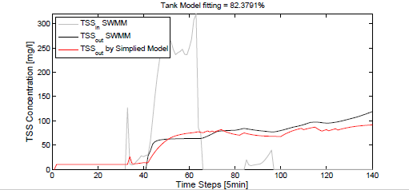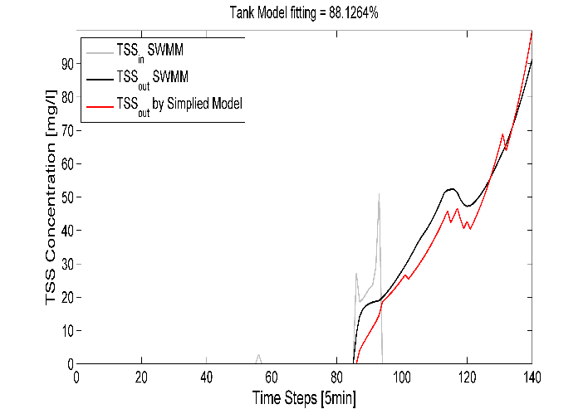
a: smaller rain scenario b: bigger rain scenario
Fig. 5. Performances of real tank model.
In future, the paper will show results of applying integrated MPC strategies in different rain scenarios and initial conditions.
The complete system performance using integrated control will be compared to the situation when Hydraulics-only MPC is applied, which will give guidelines for a larger deployment of integrated MPC of UDN and WWTPs for environmental protection in real pilots of Badalona and Bordeaux. Figure 5 shows initial calibration results of a simplified model of TSS evolution in a detention tank of Périnot in two different rain scenarios.

Conclusions
This paper shows first results of integrated MPC of UDN and WWTP using simplified conceptual models of water quality (TSS). Simplified quality models are used to represent TSS dynamics in sewers, tanks and WWTP. SWMM-TSS is used to produce realistic simulated data for calibration and validation. Results for the Perinot sewer network proves that simplified model are capable of representing main dynamic of TSS in sewer networks. MPC will use these models to compute optimal strategies taking into account both hydraulics and quality variables. This demonstration is developed as a functional prototype for larger demonstrators in real pilots in future.

Acknowledgement
This work is partially funded by grant LIFE EFFIDRAIN LIFE14 ENV/ES/00080. The technical and financial support of Bordeaux Metropole is also gratefully acknowledged.

References
Ackers P. & White W. R. 1973 Sediment transport: a new approach and analysis. J. Hydra. Divi., 99(11), 2041-2060.
Ahyerre M., Chebbo G., Tassin B. & Gaume E. 1998 Storm water quality modelling, an ambitious objectives? J.Wat. Sci. Tech., 37(1), 205-213.
Beck M.B. 1976 Dynamic modelling and control applications in water quality maintenance. J. Wat. Resear., 10(7): 575-595.
Butler D. & Schutze M. 2005 Integrating simulation models with a view to optimal control of urban wastewater systems. J. Environ. Modell. and Softw., 20(4): 415–426.
Bertrand-Krajewski J.L. 2006 Modeling of sewer solids production and transport. J. Modell. Of Sedi. Trans. And Proce., INSA de Lyon.
Cembrano G., Quevedo J., Salamero M., Puig V., Figueras J. & Martí J. 2004: Optimal control of urban drainage systems. A case study. J. Contr. Engin. Pract., 12(1), 1-9.
Macke E. 1980. Vergleichende Betrachtungen zum Feststofftransport im Hinblick auf ablagerungfreie Strömungszust¨ande in Regen-und Schmutzwasserkanälen, Braunschweig, Deutschland, 109-233.
Mahmood M., Orianne D. & Georges S. 2017 Pollution based model predictive control of combined sewer networks, considering uncertainty propagation. J. Sus. Dev. Plann. Vol. 12, No. 1, 98–111.
Meirlaen J., Van Assel J., & Vanrolleghem P.A. 2002 Real time control of the integrated urban wastewater system using simultaneously surrogate models. Water Science and Technology, 45(3):109–116.
Maruéjouls T., Vanrolleghem P.A., Pelletier G. and Lessard P. 2012 A phenomenological retention tank model using settling velocity distributions. J. Wat. Res., 46, 6857-6867.
Nash J. E. & Sutcliffe J. V. 1970 River flow forecasting through conceptual models part I-A discussion of principles. Journal of Hydrology, 10(3), 282-290.
Ocampo-Martinez C., Barcelli D., Puig V., & Bemporad A. 2012 Hierarchical and decentralised model predictive control of drinking water networks: Application to the Barcelona case study, IET Control Theory Appl., vol. 6, no. 1, pp. 62–71.
Ocampo-Martínez C., Puig V., Cembrano G., & Quevedo J. 2013 Application of predictive control strategies to the management of complex networks in the urban water cycle [applications of control]. IEEE Control Systems, 33(1):15–41.
Puig V., Cembrano G., Romera J., Quevedo J., Aznar B., Ramón G. & Cabot J. 2009 Predictive optimal control of sewer networks using CORAL tool: application to Riera Blanca Catchment in Barcelona. Water Science & Technology, 60(4): 869-878.
Richard E.R. 2016 GAMS - A User’s Guide, GAMS Develop. Corpor., Washington, DC, USA.
Rossman L.A. 2015 Storm Water Management Model User’s Manual Version 5.1, Envir. Prot. Agn., USA.
Sun. C.C., Joseph-Duran B., Maruejouls T., Cembrano G., Muñoz E., Meseguer J., Montserrat A., Sampe S., Puig V. & Litrico X. 2017 Conceptual quality modelling and integrated control of combined urban drainage system. 12th IWA Specialized Conference on Instrumentation, Control and Automation, 141-148, Quebec, Canada.
Schilling W. 1989 Real-time control of urban drainage systems. The state-of-art. London: IAWPRC Task Group on Real-time Control of Urban Drainage Systems.
Schütze M., Butler D., & Beck M.B. 2002 Modelling, Simulation and Control of Urban Wastewater Systems. Springer, London.
Schütze M., Campisano A.C., Colas H., Schilling W. & Vanrolleghem P.A. 2004 Real time control of urban wastewater systems - where do we stand today? J. Hydro., 299(3-4): 335-348.
Rouse H. 1937. Nomogram for the settling velocity of spheres. J. Comm. on Sedim., 57-64.
Vanrolleghem P.A., Benedetti L. & Meirlaen J. 2005 Modelling and real-time control of the integrated urban wastewater system. J. Environ. Modell. and Softw., 20: 427-442.
Van Rijn L. C. 1984 Sediment transport, part II : suspended load transport, J. Hydra. Engine., 110(11), 1613-1641.
Wiuff R. 1985 Transport of suspended material in open and submerged streams, J. Environ. Eng. ASCE., 111(5), 774-792.

